**PYTHON PROGRAM 1:**

**Python Program to print the pattern Input: Number of rows is 5**

**Output Pattern is:**

**A**

**B C**

**D E F**

**G H I J**

**K L M N O**

def contalpha(n):

num = 65

for i in range(0, n):

for j in range(0, i+1):

ch = chr(num)

print(ch, end=" ")

num = num +1

print("\r")

n = 5

contalpha(n)

**OUTPUT:**

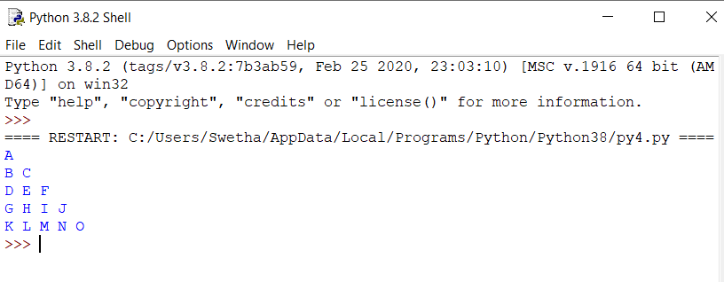

**JAVA PROGRAM 2:**

**Write a Java Program to determine whether a given matrix is a sparse matrix.**

public class SparseMatrix

{

public static void main(String[] args) {

int rows, cols, size, count = 0;

int a[][] = {

{4, 3, 0},

{5, 0, 0},

{1, 0, 6}

};

rows = a.length;

cols = a[0].length;

size = rows * cols;

for(int i = 0; i < rows; i++){

for(int j = 0; j < cols; j++){

if(a[i][j] == 0)

count++;

}

}

if(count > (size/2))

System.out.println("Given matrix is a sparse matrix");

else

System.out.println("Given matrix is not a sparse matrix");

}

}

**OUTPUT:**

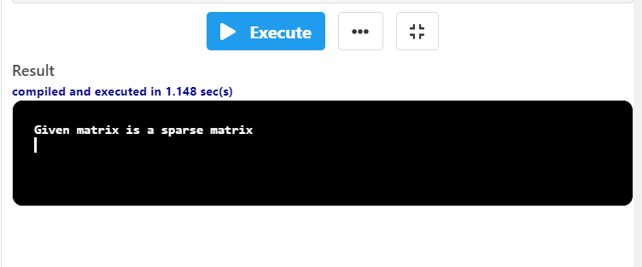

**C PROGRAM 3:**

**Write a C Program to calculate Electricity Bill.**

#include <stdio.h>

int main()

{

int unit;

float amt, total_amt, sur_charge;

printf("Enter total units consumed: ");

scanf("%d", &unit);

if(unit <= 50)

{

amt = unit * 0.50;

}

else if(unit <= 150)

{

amt = 25 + ((unit-50) * 0.75);

}

else if(unit <= 250)

{

amt = 100 + ((unit-150) * 1.20);

}

else

{

amt = 220 + ((unit-250) * 1.50);

}

sur_charge = amt * 0.20;

total_amt = amt + sur_charge;

printf("Electricity Bill = Rs. %.2f", total_amt);

return 0

}

**OUTPUT:**

